Add a Customer

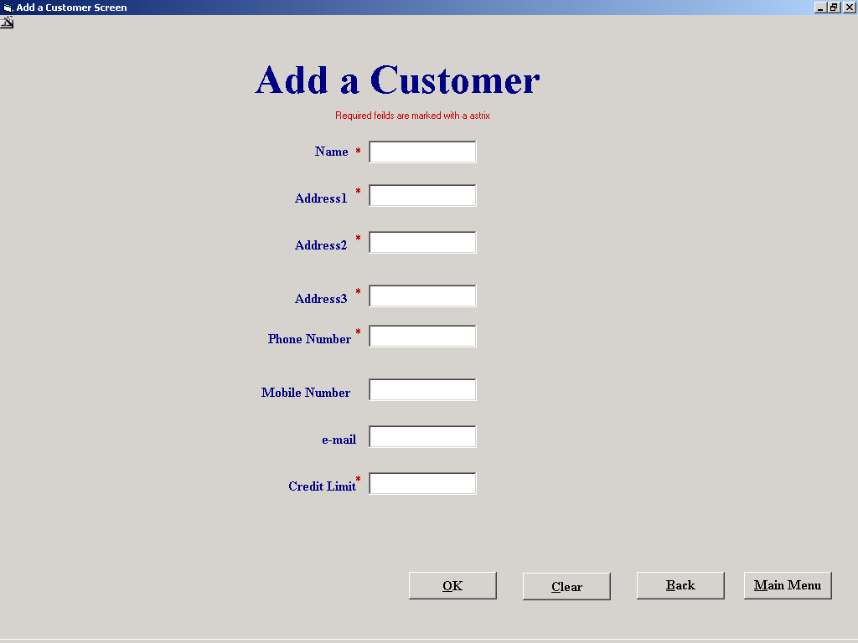

Purpose of the screen
The purpose of this screen is to allow the user to enter the details of a new customer; these will then be stored in a record with in the customer table. A unique ID number will be stored as part of the record.

How to get to this screen
This screen is opened by selecting “File Maintenance” button on the main menu, then the “Customer File processing on the File Maintenance menu followed by “Add a Customer”. Alternatively the screen can be selected from the “Hire Equipment” screen by selecting the “New Customer” button.

How to use this screen
- Enter the customers name into the “Name” input box. If this is left empty a message box will appear to prompt you to enter the information and return the cursor to the “Name” input box.

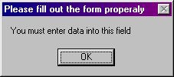

- Similarly you enter the customers address details in the data input boxes marked “Address 1”, “Address 2”, and “Address 3”. If any of these input boxes are left unfilled you will be prompted to fill them and the cursor returned.
- The customers phone number is to be entered into the “Phone number” input box and again you cannot leave this bit of information out.
- The next input box that needs to be filled is the “Credit Limit” data input box, if it is left unfilled you will again be prompted to fill in the necessary data but also if you attempt to fill this input with non numeric data you also be returned to correct your error.

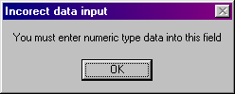

- The “email” and “Mobile phone” data input boxes need not be filled if the information is not available.
- The “Save” button takes the information entered on the screen and saves it as a new customer record. A message box prompt is given to get conformation of the save.
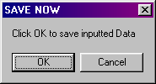

- The “Cancel” button clears the data input with out saving it. NOTE if the screen is responding to your input asking you to reenter it the cancel button can be used to clear the screen and start again.
- Selecting the “Main Menu”(alt-M) brings you to the Main menu if there is unsaved data in the screen you will be prompted to save it with a message box

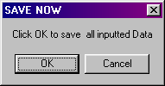

- Selecting the “Back”(alt-B) button brings you to the screen that you were in prior to this one

